**User Interface of Voice Recognition Software**

Assignment 4

**COMSATS University Islamabad**

Sahiwal Campus



**Usama Sarwar**

FA17-BS(CS)-090-B

**Mr. Ahmad Shaf**

Software Design Methodology

December 16, 2019

# Loading Screen

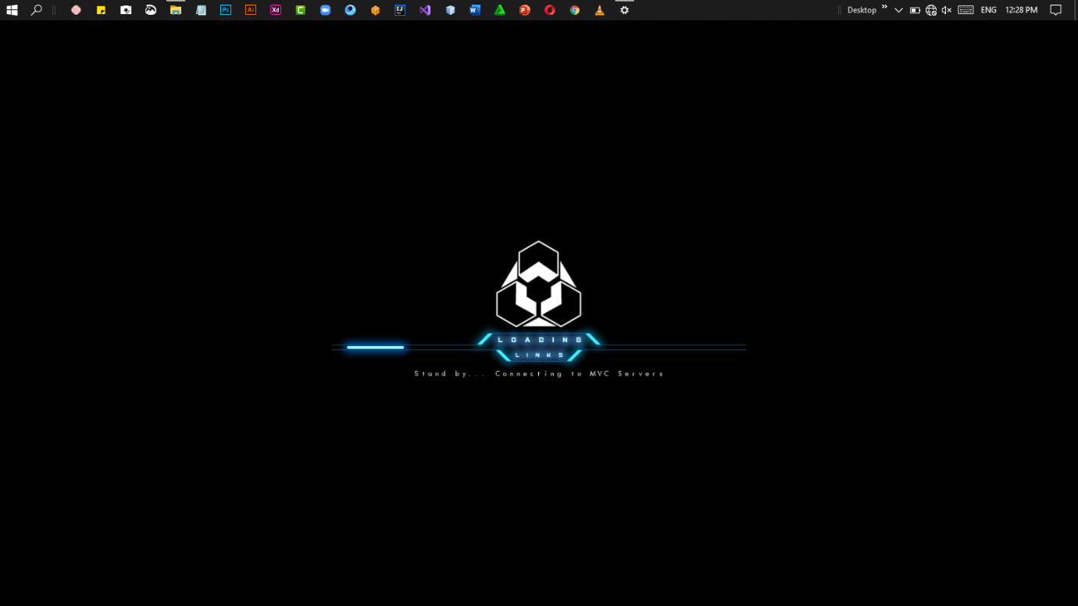

# Commands Management

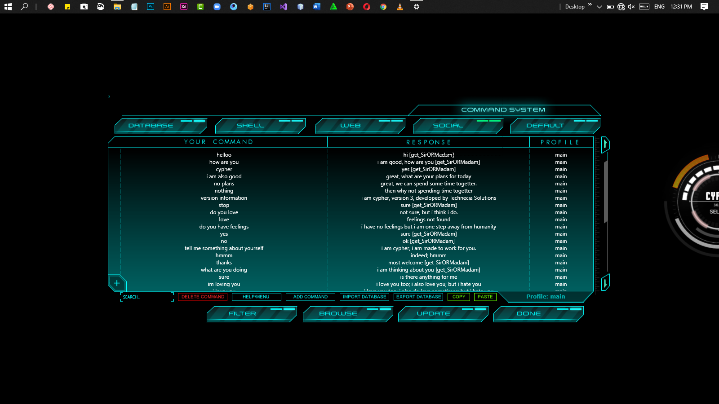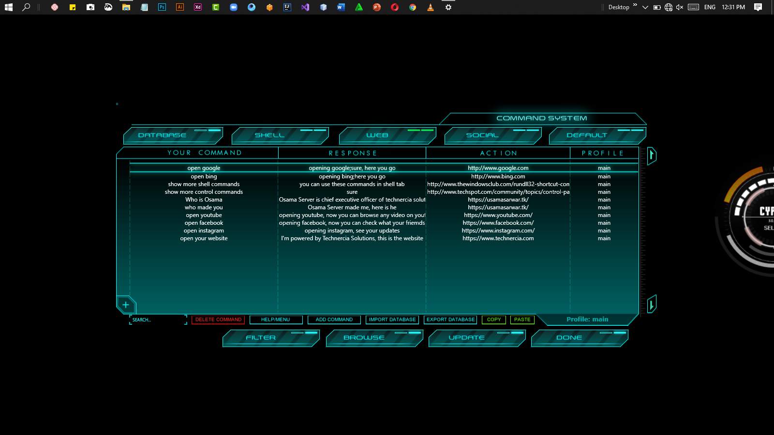

# Shell Commands

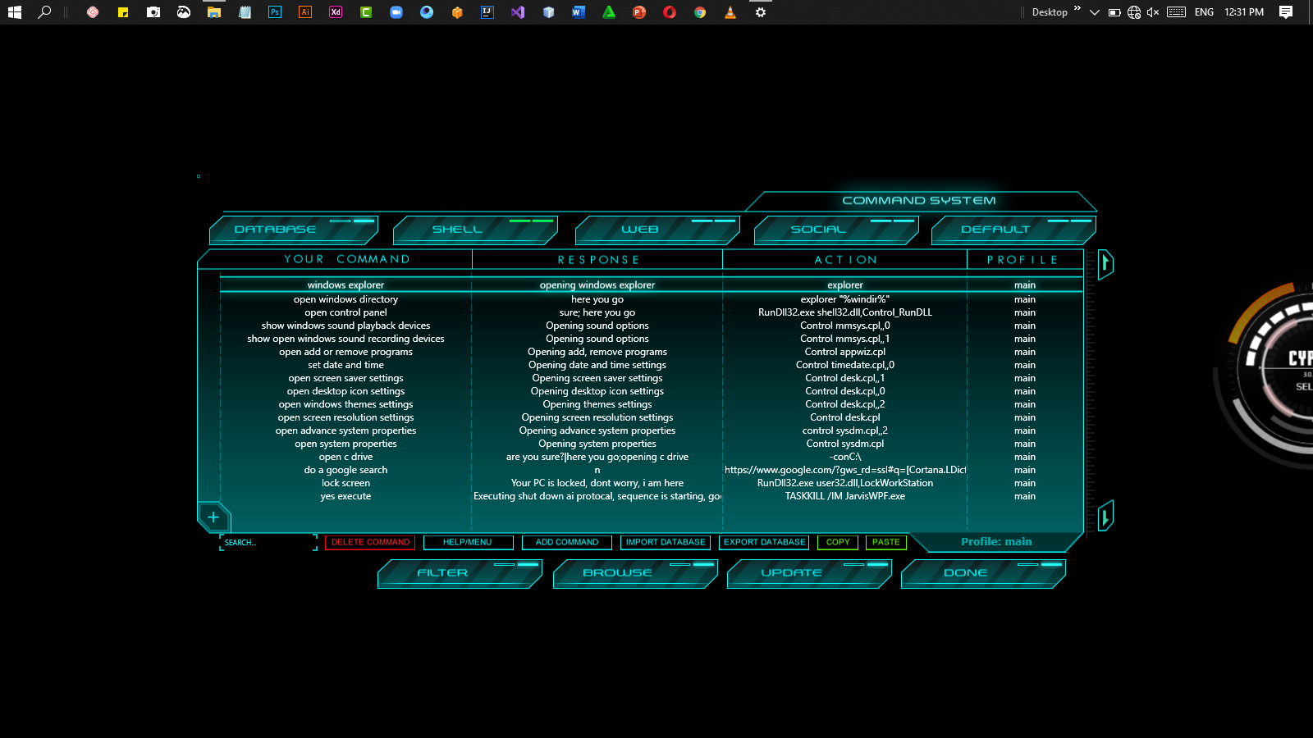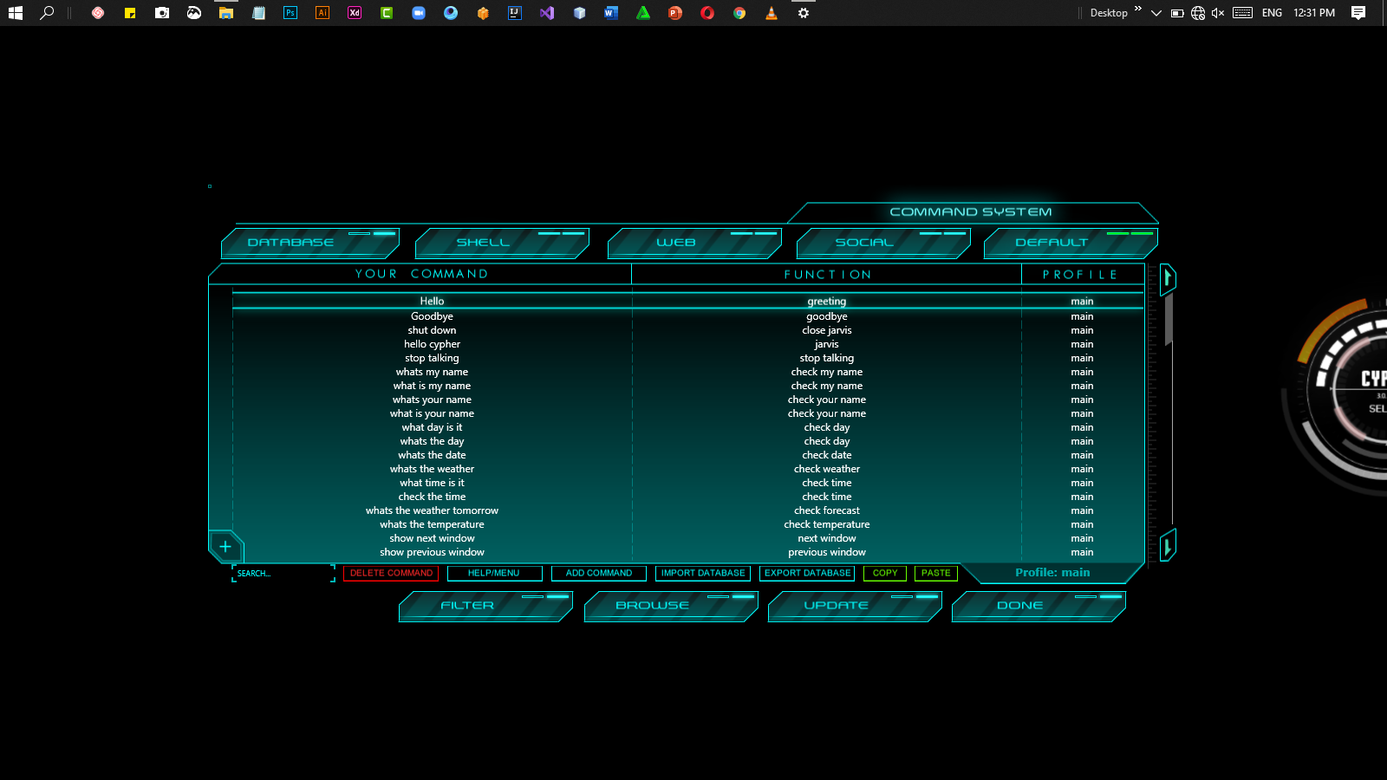

# Speech Recognition Settings

